**CS 4345: Operating Systems Practice Questions 3 (Spring 2019)** [*This is not for grading*]

[*These questions are based on deadlock and main memory concepts, including contiguous allocation, block allocation, and paging (parts of chapter-8 and chapter-9 contents of the textbook).*]

**Deadlock**

1. What are the four necessary conditions of deadlock to happen? Which are the conditions really critical for a deadlock to happen?

* **Mutual exclusion:** only one process at a time can use a resource
* **Hold and wait:** a process holding at least one resource is waiting to acquire additional resources held by other processes
* **No preemption:** a resource can be released only voluntarily by the process holding it, after that process has completed its task
* **Circular wait:** there exists a set {*P*0, *P*1, …, *P*n} of waiting processes such that *P*0 is waiting for a resource that is held by *P*1, *P*1 is waiting for a resource that is held by *P*2, …, *Pn*–1 is waiting for a resource that is held by *P*n, and *P*n is waiting for a resource that is held by *P*0.

1. What is a resource-allocation graph? How such a graph can help in modeling a system scenario?

Deadlocks can be described more precisely.

3. Discuss the usefulness of resource allocation graph and wait-for graph in deadlock detection.

4. Suppose on a system, the current resource allocation scenario is as follows:

*Requests*: P1 for R1, P2 for R3, R4, and R5, P3 for R5, P4 for R2

*Allocations*: R1 is assigned to P2, R2 is assigned to P1, R3 is assigned to P5, R4 is assigned to P3, and R5 is assigned to P4.

Assuming single instances of all these resources R1, … , R5, examine whether there is any deadlock in the current state of the system.

**Main memory**

5. Differentiate between logical memory and physical memory.

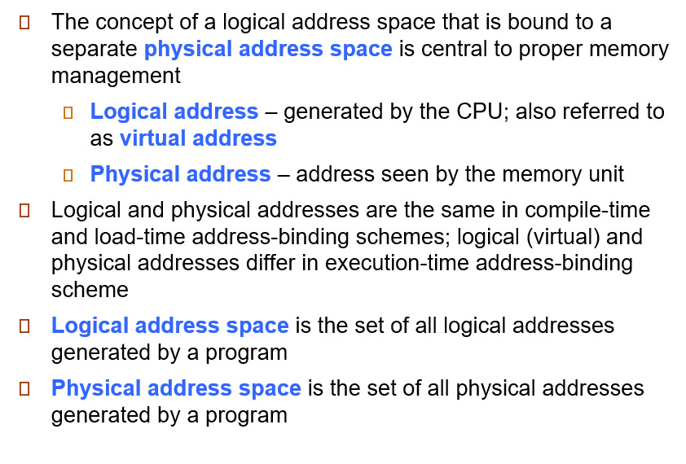

6. What is the difference between *contiguous view* and *block view* of memory?

Block view does not have contiguous memory and uses paging.

7. What are the roles of *base* and *limit* registers in memory allocation?

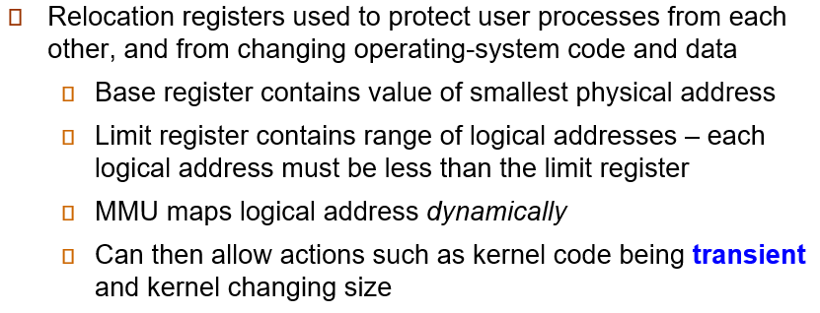

8. Explain the concept of “relocatable address space”. How is it realized (achieved/implemented)?

9. Discuss the two major types of fragmentation that can occur in address space allocation. How they can be resolved?

10. Explain the concept of *page table*. Describe how it is used by MMU in address translation.

11. Discuss the usefulness of different “fit” algorithms for memory allocation in contiguous view of memory.

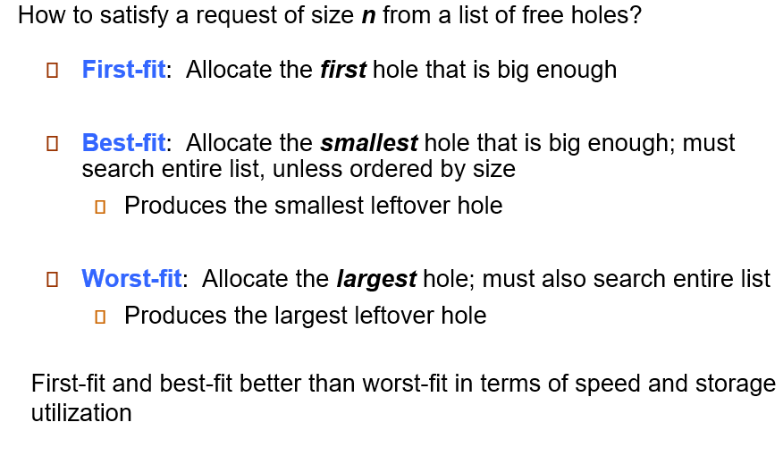

12. What is a TLB? Explain how it affects the average effective memory access time.

13. A system with 1KB (1024 bytes, where each byte indicates a memory address) page size, find the page number and offset of the following logical memory addresses: i) 3085, ii) 650000, iii) 42095

i) 3085 / 1024 =

3085 Mod

14. A logical address space has 64 pages with page size 1024 bytes and is mapped to 32 physical frames. Indicate how many bits are needed to express one logical memory address and number of bits for the corresponding physical address.

16 bits logical

15 bits physical.

15. Suppose a hypothetical OS allocates pages to frames by a heuristic that maps page number *p* to the physical frame number *2p.* On that system, a process’s address space is 128 bytes long with 16 bytes in each page. The process generates a memory reference for address 108. Under pure paging scheme, what is the physical address corresponding to this logical address?

108/ 16 = 6 page

108 Mod 16 = 12 Address number

12*6+12 = Physical Address = 204